User Guide

Glasgow International Airport

Contents

- About this document
Intended audience……………………………………………………………………………………………… 3
Overview

- Using the Staff Portal
Registration………………………………………………………………………………………………………… 4
Staff details………………………………………………………………………………………………………… 5
Document Approval….……………………………………………………………………………………….. 6
Apply for Permit…….….……………………………………………………………………………………….. 7
Vehicle Details….……………………………………………………………………………………………….. 8
Finalise Booking….…………………………………………………………………………………………….. 9
Booking Confirmation….………………………………………………..……………………………………10
Renew/Change Details….…………………………………………………………………………………….11
Leaving Current Employer….………………………………………………………………….……………12

- About This Document

Intended Audience
This document is intended for all staff that require on site parking at Glasgow Airport.

Overview
The staff portal is operated online through the web and can be accessed with any device with a web based browser
Staff are required to register on the Portal with their details including vehicle registration number and parking area required.
No parking will be available until registration is complete and approved by the relevant business partner.

2 . Using the portal

Accessing the Portal online
Staff can access the online Portal by typing https://_{glasgowstaff}.apcoa.co.uk
(Save to favourites as this will be required to change details)

Registration
Staff will need to create an account using an email address and password. Passwords need to contain at least 1 x Uppercase letter, 1 x Lowercase letter and be a minimum of 6 characters in length. See example screen below

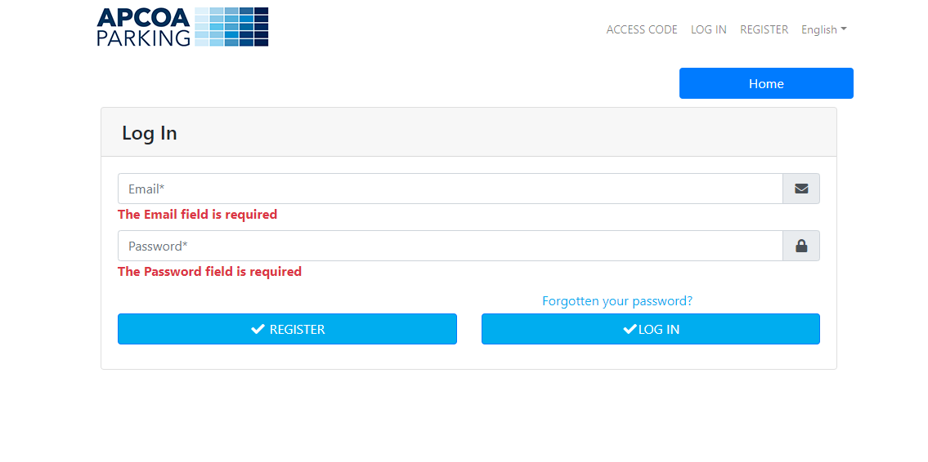
Please click ‘Register’ to proceed to next screen

Staff Details

Staff are required to complete ALL fields on the below screen
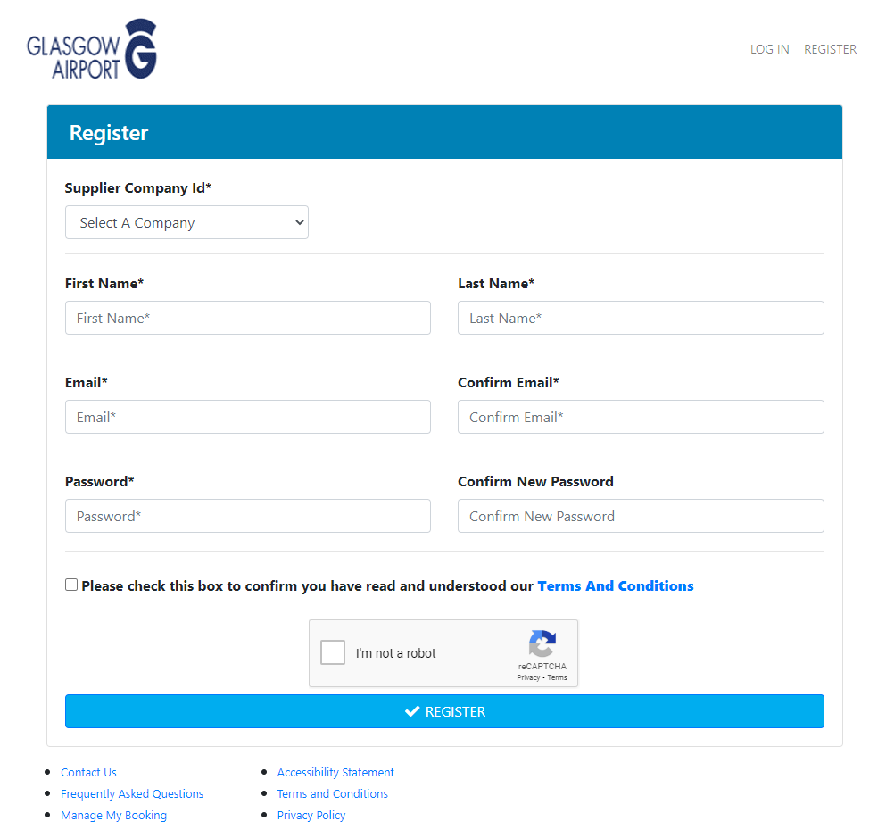
Suppler Company Id – Select which company you are working for from the drop down box.
First/Last Name – Type your name in the fields provided
Email – Enter email address
Password – Enter password
Ensure you tick you have read the T&C’s and click Confirm on the pop up window.
Click the ‘I’m not a robot’ box.
Click ‘Register’ to continue.

Document Approval
A document submission is required for parking approval.
Please click on the down arrow next ‘Welcome’ on top right of page.
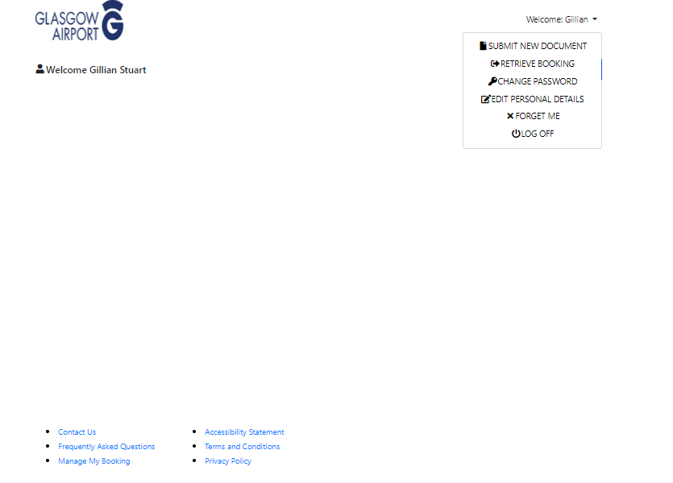

Select ‘Submit New Document’
Click ‘Upload File’. Accepted documents are Airport ID badge or Driving licence or Passport if awaiting ID badge
Tick in box to confirm you wish to submit uploaded document
Click ‘Submit New Document’
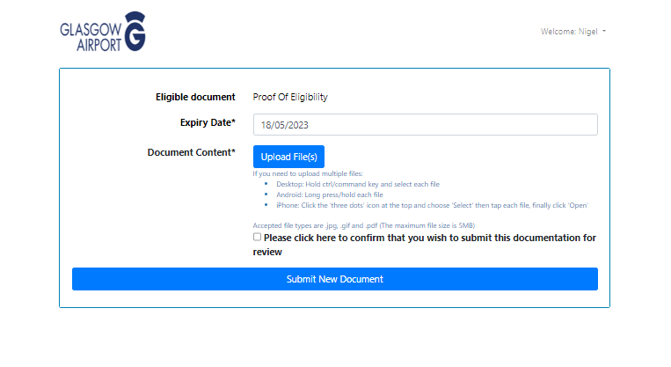
You will not be able to proceed until you have received an email informing you of approval of your document.
Apply for Permit
Click on ‘Apply for New Permit’
On next screen please select car park you have been allocated.
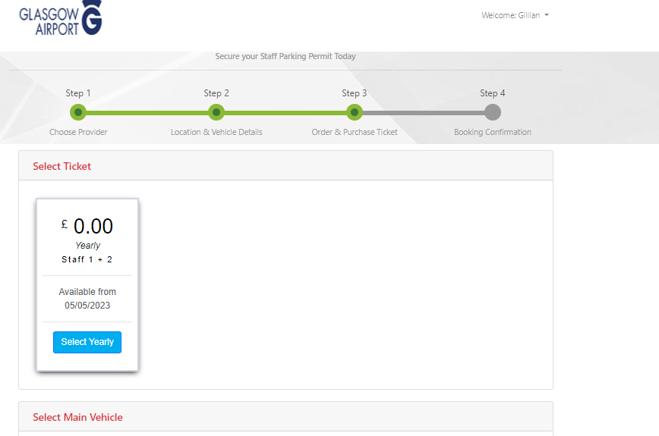

Vehicle Details
Click on ‘Add Vehicle and complete all details of your vehicle in the POP Up
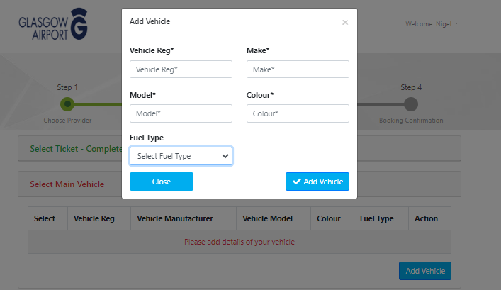
Click ‘Add Vehicle’ when all field completed.

You can add multiple vehicles but only 1 can be active per day. A change in selected vehicle can take 1-2 hours to update on the system.
Finalise Booking
Please enter the start date parking is to commence. Permits will be valid for 2 years.
Tick to accept T&C
Click ‘Book Now’
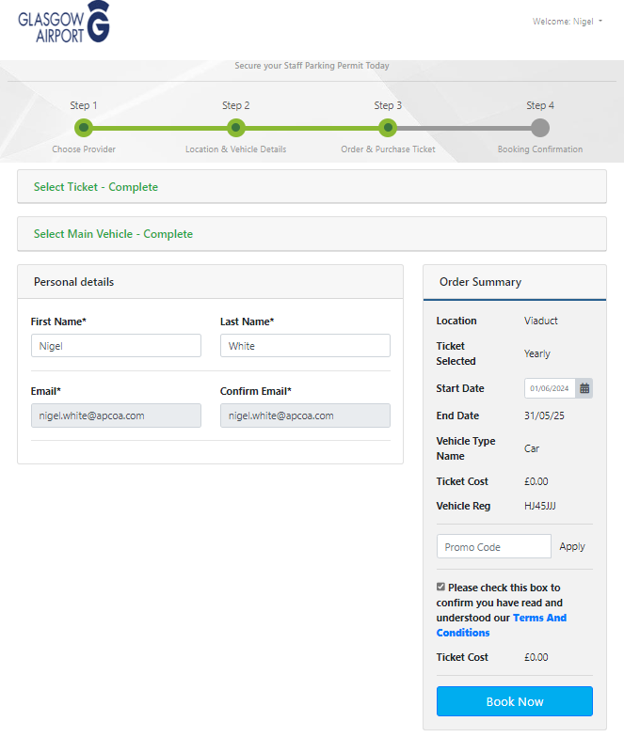

Booking Confirmation

Once booking is successful, you will be taken to a confirmation screen as shown below.
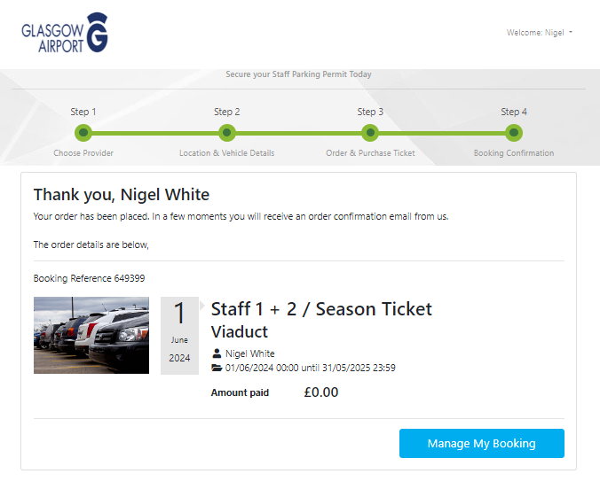
An email confirmation will also be sent to the email address used for registration.

Renew/Change details.
Log into the Staff Portal using same web address: https://glasgowstaff.apcoa.co.uk

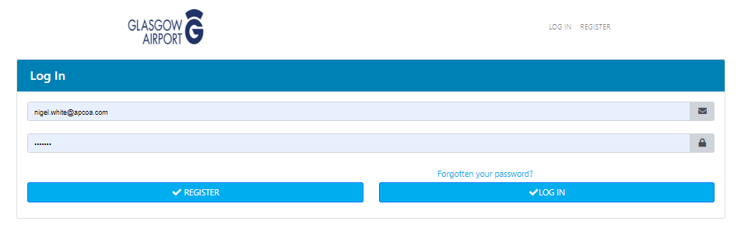
Click the option you require – Renew, Change Vehicle Details or Cancel Permit.

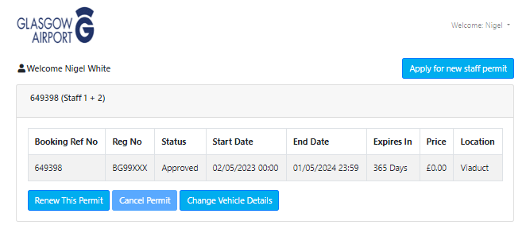
Click Change Vehicle to Edit, Delete or Add a new vehicle registration or, change which vehicle you are using.

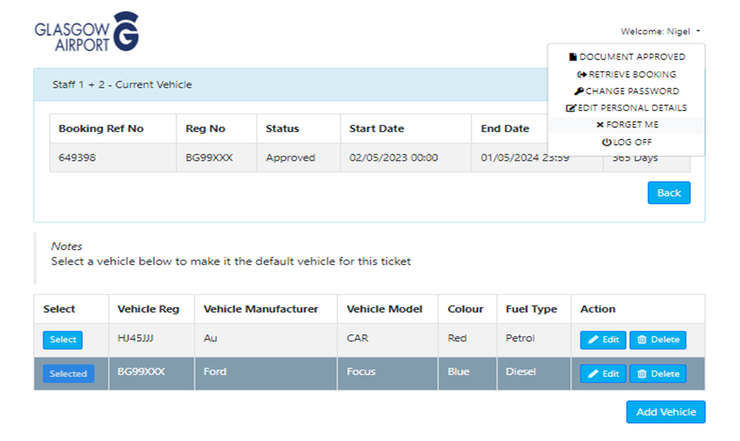
Leaving your current Employer

Click Forget me
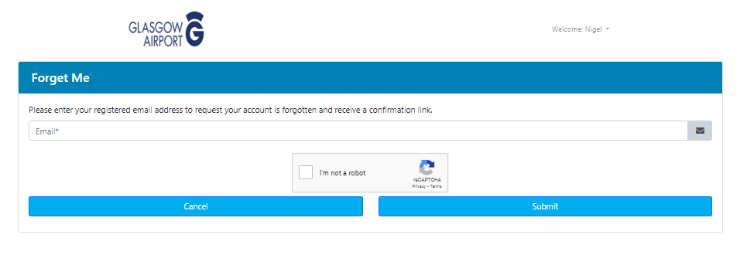
Enter the email address, tick in box ‘I’m not a robot’ and click submit.
You will receive an email with a link to click. Click on link to finalise cancellation of staff parking permit.
If you change employers within you WILL HAVE to apply for a new permit.

